**ASSIGNMENT-9**

U19CS012

**1.** Calculate and Plot Vo for the following circuit.



A.) Multisim Calculations:

*1.) Circuit Image:*

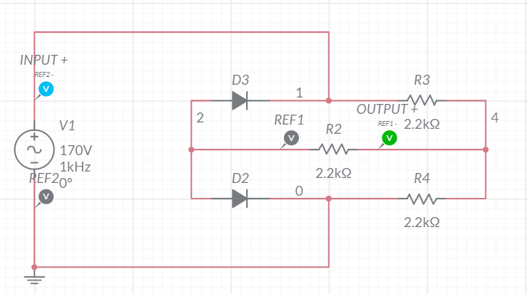

*2.) Grapher Image:*

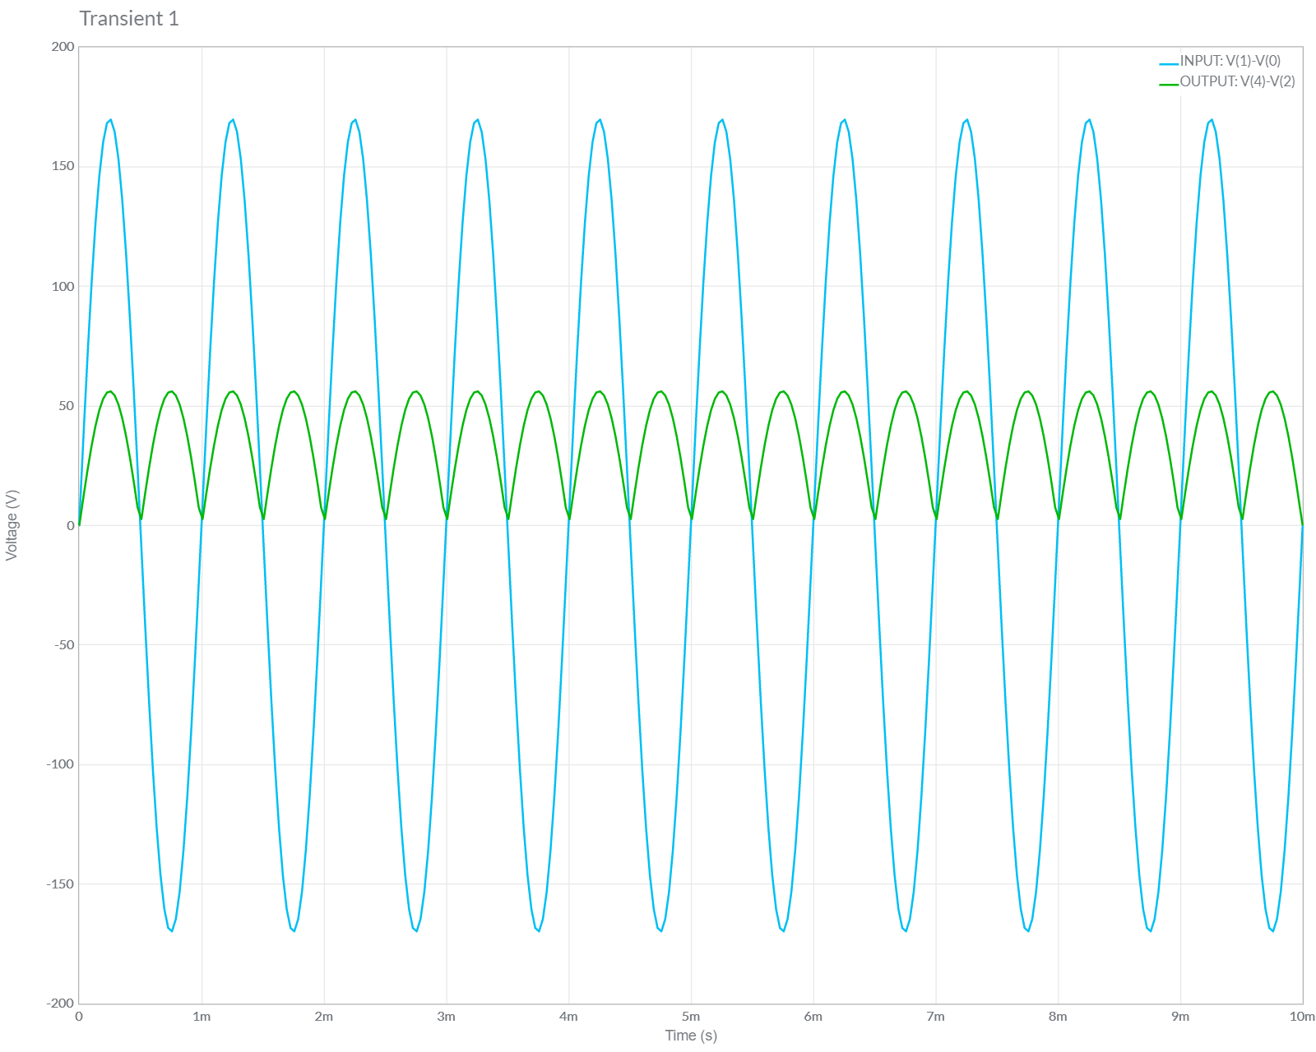

B.) Calculation Part

